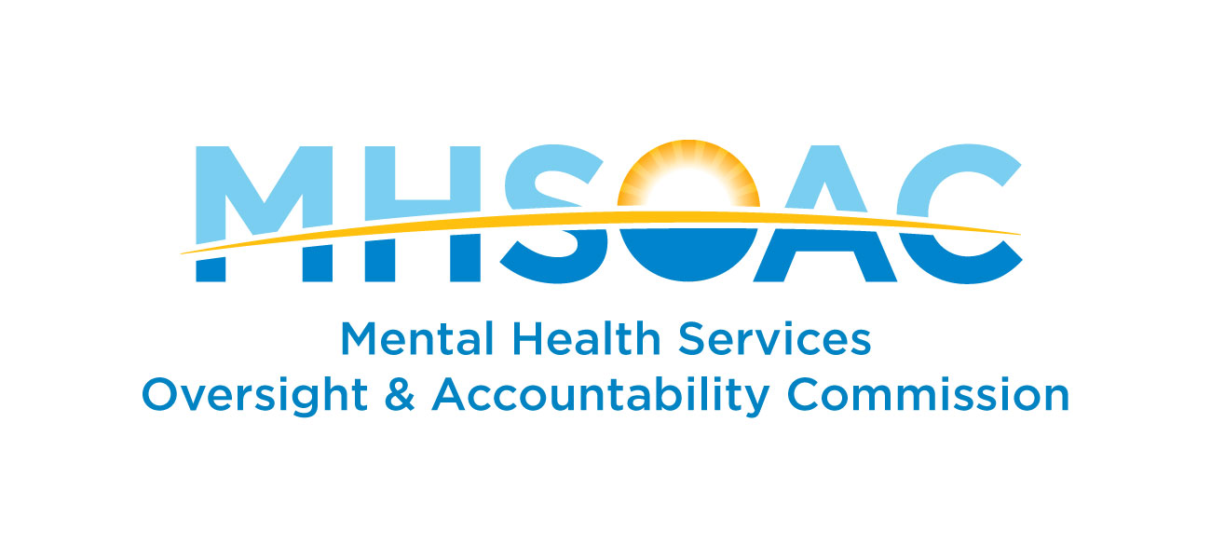

Research and Evaluation Committee Charter
2020-22

Purpose
The Commission’s vision is wellbeing for all Californians. The Commission works through partnerships to catalyze transformational changes across service systems so that everyone who needs mental health care has access to and receives effective and culturally competent care.
Research and evaluation are critical to this mission. The Research and Evaluation Division guides the MHSOAC’s assessment activities. Its goal is to generate new insights, promote continuous learning, and drive improvements in public health and policy. To do this, the MHSOAC develops knowledge tools and products through original research and contracted activities. The Division also works closely and collaboratively with stakeholders including clients and their family members, and representatives from underserved communities to ensure the values of the Mental Health Services Act (MHSA) are incorporated into research and evaluation activities.

The Research and Evaluation Committee, comprising a diverse, interdisciplinary group of professionals, provides guidance and expertise that reflects a broad understanding of the opportunity for driving transformational change using research to improve prevention and innovation, as well as mental health services and supports. The Evaluation Committee supports the MHSOAC in reaching its strategic goals and ensuring that information disseminated is timely, accurate, resonant with the needs and experiences of mental health consumers, and useful to improving community wellness and client recovery.

Core Functions
The core functions of the Committee are to provide expert advice and guidance to the Commission to ensure that the Research and Evaluation Division meets the needs of the Commission. The Commission has entrusted the Research and Evaluation Division with the following responsibilities to realize transformational change across service systems:
- Document Programs & Services
- Guide reports, evaluations, and tools that document various activities funded by the Mental Health Services Act (MHSA) and their characteristics.
- Measure Outcomes
- Refine measures for the seven negative outcomes – school failure, out-of-home placement, incarceration, suicide, homelessness, unemployment, and prolonged suffering.
- Guide evaluation projects, activities, and reports designed to assess the impact of programs and services (e.g. access to care, consumer satisfaction, and consumer well-being).
- Ensure Fiscal Accountability
- Guide the evaluation of MHSA funding, focusing on program costs and the cost offsets in other areas (e.g., hospitalization) when programs are implemented.
- Review and guide the development of MHSOAC tools for promoting transparency and accountability in MHSA program finances.
- Improve Data Quality
- Guide the development of planning tools, training resources and webinars designed to improve the quality of consumer-level data submitted to the State Data Collection and Reporting (DCR) System by local mental health agencies.
- Shape Policy
- Support and guide recommendations for research and evaluation derived from the Commission’s policy projects.
- Advise Other MHSOAC Activities
- Support the Commission’s processes for engaging diverse communities and using that information to reduce disparities and improve mental health outcomes.
- Provide subject matter expertise for request for applications (RFAs).

2020-21 Committee
Leadership
Commissioner Itai Danovitch, M.D., Chair
Commissioner Ken Berrick, Vice Chair

MHSOAC Staff
Dawnté Early, Ph.D., MS, Chief of Research and Evaluation
Kai LeMasson, Ph.D., Senior Researcher

Members
Rikke Addis, M.A.
Sergio Aguilar-Gaxiola, M.D., Ph.D.
Robert H. Brook, M.D., Sc.D.
Victor G. Carrión, M.D.
Eleanor Castillo Sumi, Ph.D., BCBA-D
Jonathan Freedman, MSPH
Sharon Ishikawa, Ph.D.
Bridgette Lery, MSW, Ph.D.
Gustavo Loera, Ed.D.
April Ludwig, LMFT
Belinda Lyons-Newman, MBA
Laysha Ostrow, Ph.D.
Mari Radzik, Ph.D.
Ruth S. Shim, M.D., M.P.H.
Lonnie R. Snowden, Jr., Ph.D.
Katherine Watkins, M.D., M.S.H.S.

Meetings
The committee will meet at least quarterly and more often as needed. A majority of the committee members shall constitute a quorum. The committee will review its charter annually and recommend any proposed changes for review.

